****Tarlac State University

**COLLEGE OF COMPUTER STUDIES**

Case Study

in

Integrative Programming Technology 2

Submitted By:

**Emmanuel Palasigue**

**Bill Homer Sapon**

**Patrick Dave Sagun**

**Juan Antonio David**

Submitted To:

**Mr. Kwinno Pineda**

Date: March 11, 2023

Table of Contents

A. Definition 2

B. Case Analysis (Git and GitHub Workflow) 3

B.1 Documentation 3

C. References 4

# Definition

Create a static website upload the documentation and files in your GitHub repository each members will upload their webpage online using Git to GiHub development create a documentation your case study.

**Requirements:**

* Each member in your group will need to upload **a webpage**
* Create a **Pull Request** for each member in Github with comments.
* Create an **Issue** for each member in Github and comment.
* Create a **Milestone** for the group in Github.
* Create a branch for each member and merge it with your maste/main branch in Github.

**Define and describe how you use of each command with screenshot in your case study.**

* Git clone
  + a command that copies an entire Git repository, including all the files, branches, and changes. It lets you download the repository onto your computer so you can work on it locally.

syntax of git clone: git clone <https://github.com/Emmanu29/MidtermCaseStudy.git>

* Git Pull
  + a command that updates your local Git repository with the latest changes from the remote repository. It fetches and merges all the changes made in the remote repository since your last sync.

syntax of git pull: git pull

* Git Push
  + a command that uploads your local changes to a remote Git repository. It publishes your changes to a shared repository, allowing others to access and review your work.

syntax of git push: git push origin HEAD:<branch>

* Git Fetch
  + a command that downloads changes from a remote Git repository without merging them with your local repository. It shows you the latest changes made by others without affecting your local work.

syntax of git fetch: git fetch

* Git Merge
  + a command that combines changes from multiple branches into a single branch. It allows you to integrate changes made by you or others into the main branch of the repository.

syntax of git merge: git merge <branch name> or git merge –no-ff <branch name> -m <message>

* Issue
  + An issue is a task or problem that needs to be resolved in a project. It is used to keep track of work and manage it in a repository.

* Pull Request
  + A pull request is a way to request merging changes from one branch of a repository into another. It is used for code review and collaboration before merging the changes into the main branch.

* Milestone
  + A milestone is an important point or event in a project's timeframe. It is used to track progress and ensure that work is finished on schedule.

* Branch
  + A branch is a separate line of development that enables developers to work on changes without affecting the main codebase. Branches are commonly used to create new features or fix problems while keeping the main branch stable.

# Case Analysis (Git and GitHub Workflow)

## Documentation

Create a narrative documentation, take screenshots to tell and proof your case study. List the things you have done and how you did to the case study, the commands you have use with screenshots. Include **git log** screenshot as reference of history of your commit in your documentation.

Project: Theatre Record

Objective: To create a comprehensive and user-friendly website for movie lovers, providing the latest information on movie releases, trailers, reviews, and ratings.

Scope: The website will feature of movie titles, including new releases and classic films, as well as a section for movie trailers, reviews, and ratings. Users will be able to search for movies by title, genre, release date, and other criteria, and will be able to create a personalized account to save and share their favorite movies.

Implementation:

Planning: The first step in creating the movie website was to define the scope of the project and create a plan for implementation. We identified the necessary features and functionality for the website and created a site map and wireframes to guide the design and development process.

Design: Once the site map and wireframes were complete, we moved on to the design phase. We chose a clean and modern design aesthetic, with a focus on usability and accessibility. We created a custom color palette and typography system and designed a logo and other branding elements to give the website a cohesive and professional look.

Development: With the design in place, we began the development phase of the project. We built the website using HTML, CSS, and JavaScript. We also created a user registration and login system and implemented functionality for searching and filtering movies.

Testing: Once the website was complete, we conducted extensive testing to ensure that all features and functionality were working properly. We tested the website on a variety of devices and browsers, and addressed any bugs or issues that arose during testing.

**Log-in page**

**Admin Page**

**Main Page**

**Series page**

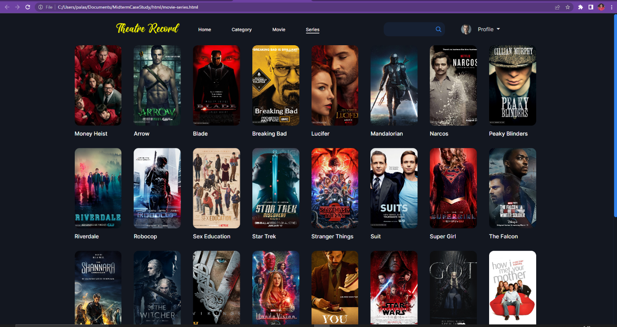

**MOVIE LIST PAGE**

**GIT LOG**

**GIT CLONE**

**GIT ADD**

**GIT COMMIT -m “ “**

**GIT STATUS**

**GIT PUSH ORIGIN HEAD:MAIN**



**GIT PULL ORIGIN MAIN**

# References

Use IEEE format.

**Grade Matrix:**

Git Command : **20%**

GitHub Implement : **20%**

Documentation : **40%**

Webpage (Development) : **30%**

**100%**